**Kentucky Employers’ Mutual Insurance**

**Request for Proposals (RFP) No. 2025-105**

**Purpose:** **Data Visualization/Analytics Tool**

The procurement by competitive negotiation is desired by Kentucky Employers’ Mutual Insurance (hereinafter “KEMI”) for a data visualization/analytics tool.

Responses must be submitted electronically, in a single PDF document limited to 100MB, via KEMI’s online procurement submission portal at: [www.kemi.com/rfp](http://www.kemi.com/rfp)

The online procurement submission portal utilizes a two-step process to upload responses. Vendors must complete the access request form by providing contact information and a valid email address.  An access link will be sent to the email address provided.  Vendors must then follow the access link to the proposal submission form.

Proposals must be submitted on or before: **12:00 PM Eastern Time on September 3, 2025**

**Table of Contents**

1. RFP Specifications
2. Proposal Requirements
3. Instructions
4. General Information

**Addendum:**

Offeror Information

Sworn Statement Regarding Campaign Finance Laws

Proposal Submission Checklist

Business Continuity Form

1. **RFP SPECIFICATIONS**
2. Purpose and Scope of Services

To procure a Data Visualization/Analytics software tool to provide interactive dashboards for use by both internal KEMI employees and external policyholders/agents.

1. Scoring

A committee will evaluate all responses to ascertain which Offeror(s) best meets KEMI’s business needs and requirements based on the selection criteria below:

|  |  |
| --- | --- |
|  | **Maximum Points Possible** |
| **Essential Functionality** | **50** |
| **Optional Functionality** | **20** |
| **Training Tools/Support** | **15** |
| **Pricing** | **10** |
| **Business Continuity Form** | **5** |
| **MAXIMUM POINTS POSSIBLE** | **100** |
| **Interviews/Discussions, if selected** | **100** |
| **MAXIMUM POINTS POSSIBLE**  **With Interviews/Discussions** | **200** |

1. Schedule of Events

The following schedule of events represents KEMI’s best estimate of the schedule that shall be followed. KEMI, in its sole discretion, may alter and/or amend this schedule at any time, including not conducting virtual interviews/discussions. Any adjustments to the schedule of events will be emailed to the prospective offeror’s contact on record with Sarah Kosin.



* RFP Publication Date – Wednesday, July 30, 2025
* Deadline for Inquiries – Wednesday, August 6, 2025
* KEMI Response to Inquiries – Wednesday, August 13, 2025
* Deadline for Submission of Proposals – Wednesday, September 3, 2025
* Virtual Interview/Demonstrations (Optional) – Beginning September 22, 2025
* Estimated Contract Award – January 1, 2026

1. **PROPOSAL REQUIREMENTS**
2. **Essential Functionality**

Please confirm your company can satisfy the following, and where appropriate, describe how your company satisfies the following:

**Data Connectivity/Data Source Management**

* Must have the functionality to connect to:
  + Oracle Database
    - Must be able to connect and perform efficiently to BI Database views and tables in our private AWS account. Our current software uses a bridge application running within our private subnet. It has access to our databases and can reach out through the internet to communicate with our Cloud-based Data Visualization tool.
    - Must be able to connect to Oracle Databases running in Amazon RDS.
    - Must be able to connect to and perform efficiently to Custom SQL code stored in the data visualization tool.
  + Excel and CSV files
    - Must be able to connect and perform efficiently to Excel/CSV files stored on private company file shares. Our current software uses a client installed on the local machine of the users with permissions in the data visualization tool to publish dashboards. The data from the file share is accessed with local permissions and then published to the cloud server. Direct access to private shares does not occur. If updates are made to the file(s), we must republish the dashboard to the server to see those updates reflected. We could also modify our workflow to store our Excel/CSV files in private cloud storage such as Amazon S3.
    - Must have the ability to perform data transformations/custom formulas based on fields found in Excel/CSV files.
    - Must have ability to connect to multiple Excel/CSV files and read multiple worksheets within one file in a dashboard.
* Must have the ability to connect to multiple types of data sources (ex. connecting to Oracle Database and Excel files) in the same dashboard.
* Ability to set up published data sources and/or data extracts to utilize as data sources for dashboards to reduce strain/load on our database, reduce load time for end-users, and enable offline access to data.
* Would be a plus to have the functionality to connect to:
  + SQL Server
  + Other Amazon Database technologies such as Aurora, Redshift, or RDS for PostgresSQL.
  + Oracle databases running on Amazon EC2.

**Data Visualization Options**

* Must have the ability to produce the following visual types. These types of visuals are found throughout our external KEMI.com dashboards and key internal dashboards.
  + Basic Chart/Table

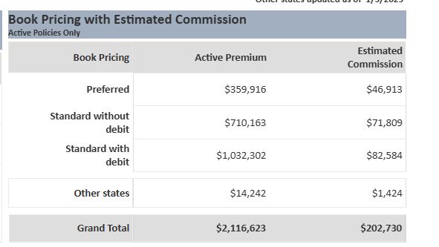

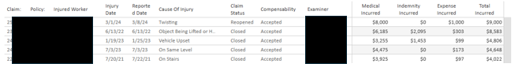

* + Bar Chart/Stacked Bar Chart

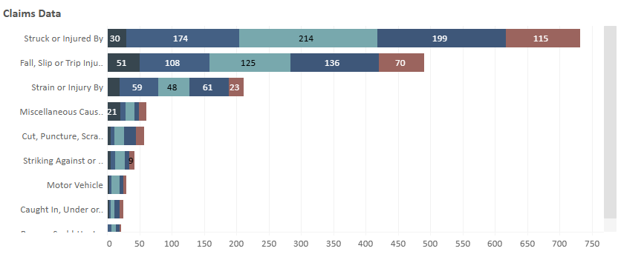

* + Line Chart

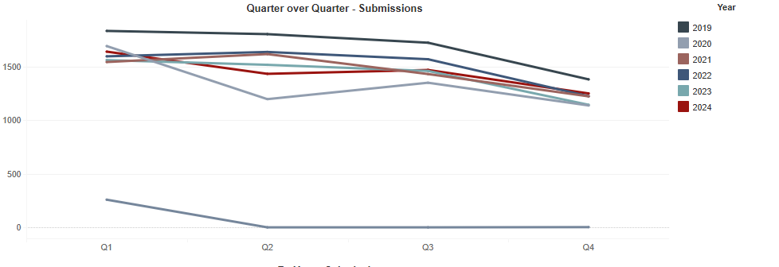

* + Combination Bar/Line Chart

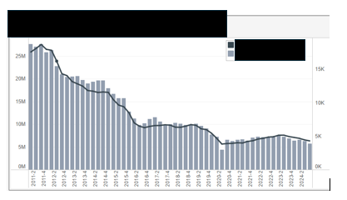

* + Pie Chart

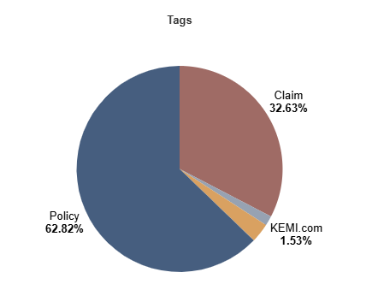

* + Scatterplot

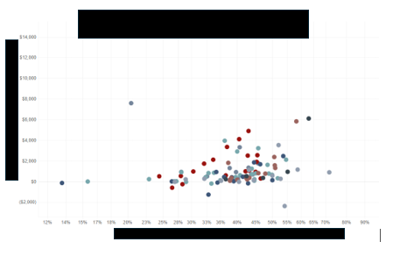

* + Box and Whisker Plot

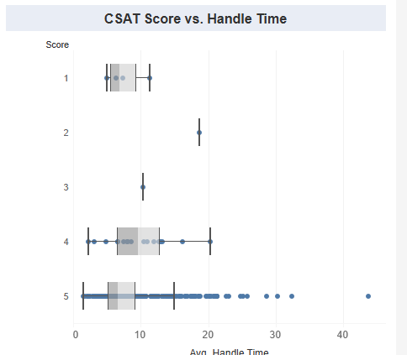

* + Map (Geographic)

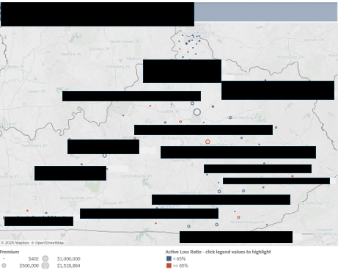

**Dashboard Tool Functionality**

* Custom Formulas/Fields
  + Ability to create custom formulas utilizing fields found in our database or other data connections.
    - Example: Active Loss Ratio is calculated within dashboards by dividing Total Losses by Earned Premium. This is not optimal to store to in our database, so the calculation takes place within the dashboard as a custom calculation.
  + Ability to create custom groups, sets, and hierarchies of available data fields.
    - Ability to drill-down into different levels of hierarchies.
      * Example: Quarter and Category have been added to a hierarchy. Selecting the plus button breaks the quarter down further by category:

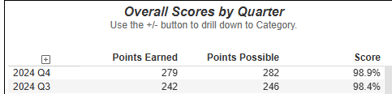

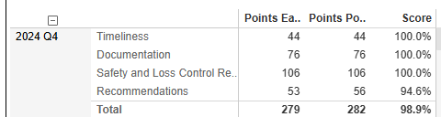

* + Ability to insert dynamic data fields and conditional text into text boxes.
    - Examples: Valuation Date field comes from a field in our database and updates dynamically. The policyholder’s name also updates dynamically. The text about KSBIT is coded to display only in certain scenarios.

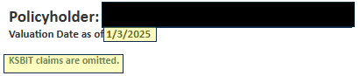

* Filters
  + Back-end data source filters that can be applied to entire dashboards, specific tabs/worksheets, or specific visuals.
  + Front-end filters that end-users can interact with and apply as needed to dashboard.
  + Utilizing visuals as filters for other visuals on a dashboard through a click/selection.
    - Example: Selecting the row for Hazard Group A filters the other present visuals to only show that grouping.

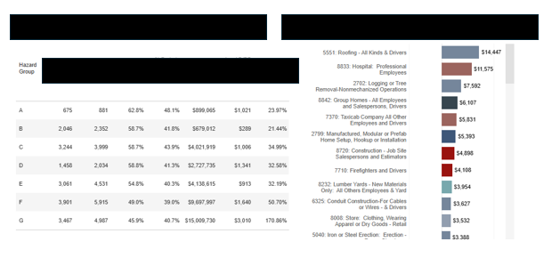

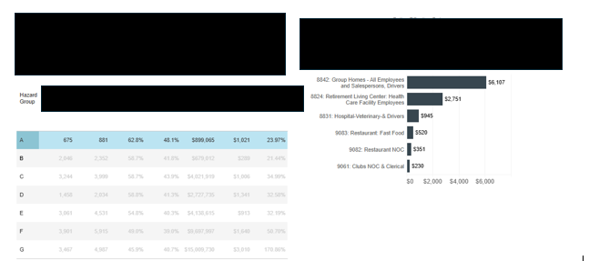

* Sorting
  + Ability for the end-user to sort data table visuals.
    - Need ability for at least one of these sort methods:
      * Ability to choose field to sort by from a dropdown menu and select whether to sort in ascending or descending order.

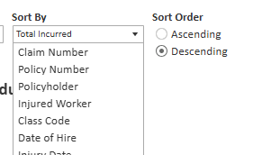

* + - * Ability to sort a table by clicking a field’s row label at the top of the visual. Clicking again would alternate between ascending/descending order. Example – clicking on “Injury Date” to sort the visual by Injury Date.

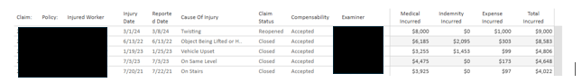

* Filter/Parameter Visual Swappers
  + Filter and/or parameter (terminology may differ based on vendor) functionality that allows for swapping between different visuals based on user input.
  + These can swap in the following ways:
    - Swapping the metric displayed
    - Swapping the field displayed on an axis
    - Swapping to an entirely different visual(s)

Example: Selecting either Incurred or Claim Count to change the metric shown.

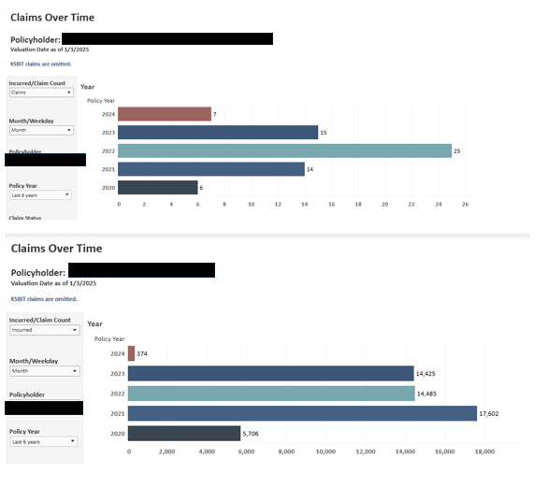

Example 2:

Selecting one of two options in the “Choose View” dropdown to change the visuals shown throughout the sheet.

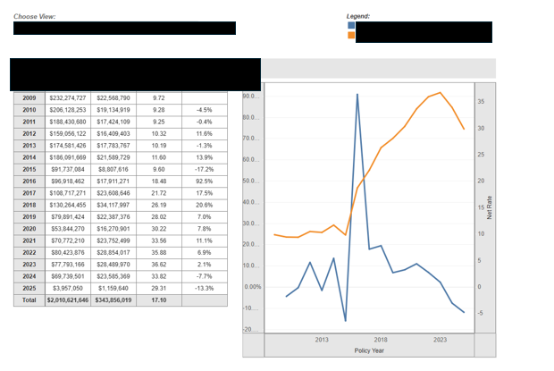

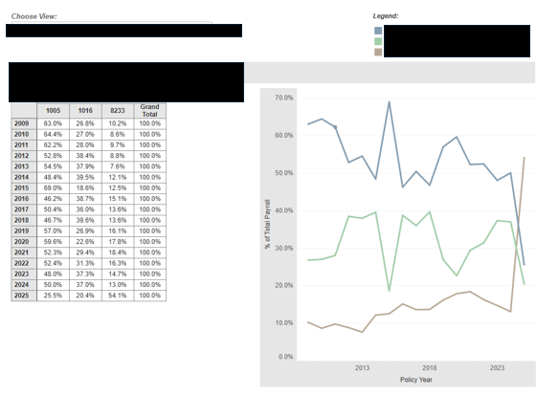

* Ability to track KPI status for internal strategy dashboard.
  + Needs ability to set threshold, target, and max marks on visuals.

Example:

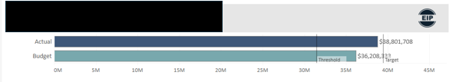

* Ability to insert images, such as the KEMI logo and EIP indicator.
* Ability to insert icons to display progress of yearly goals.
* Ability to set up access to other areas/tabs of a dashboard through one click.
  + Example – top bar menu found in our Strategy Dashboard.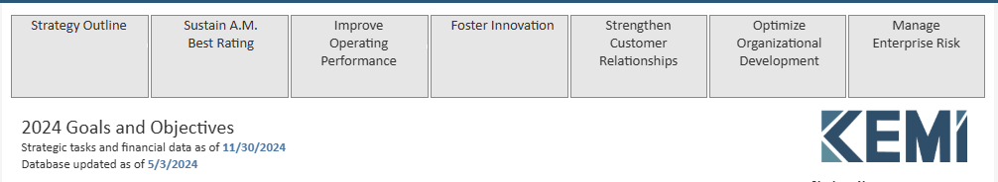
* Color Formatting:
  + Ability to customize color formatting in visuals.
    - Ability to apply a default color scheme to entire dashboards to follow KEMI stylebook guidelines and maintain consistency.

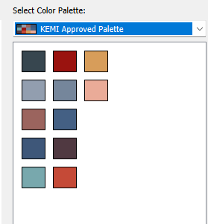

* + - Ability to apply a dynamic color scheme based on a field.
      * Example: In this visual, the value for Active Loss Ratio determines if the color is red or blue. If the value is >65% the bar is red and if the value is <65% the bar is blue.

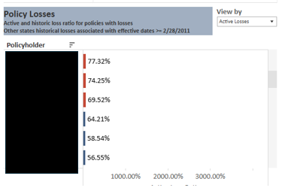

* Ability to assign custom map logic based on county.
  + Example: In this dashboard, each county is coded to count towards a particular region. These counties appear on a map visual color-coded per the region they are assigned to.

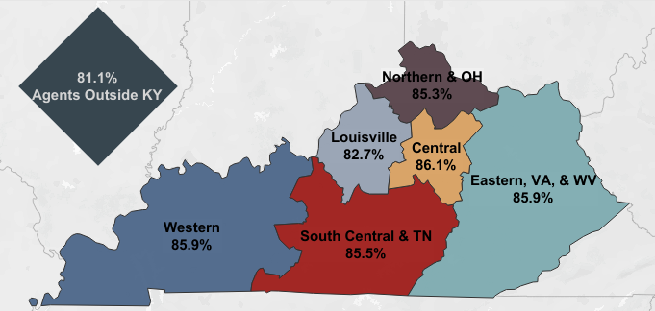

* Tooltips and Links

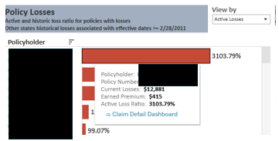 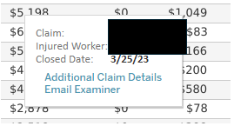

* + Ability to utilize hover-over tooltips, or similar functionality, to display relevant additional information that is not included in a visual. This is needed when information needs to be included but is not practical to include in the visual itself due to space.
  + In tooltips, the ability to embed links is needed. We utilize the following types of links in external KEMI.com Dashboards:
    - Link to other worksheets within the same dashboard. When clicking the link, filters that are applied to the source visual need to carry through to the destination worksheet.
    - Link to other dashboards. For example, a link from the Agent Dashboard to the Claims Detail Dashboard. When clicking the link, filters that are applied to the source visual need to carry through to the destination dashboard.
    - Links to URLs.
      * Links to other areas of the KEMI.com website.
        + Example: Links to Make a Payment screen and Policy Home screen from Agent Dashboard.
      * HTML Mail-to link
        + On the Claims Detail Dashboard, an HTML mail-to link to email the examiner for any claim is included in the hover-over tooltip. This link auto-populates the subject line for the email with the claim number in the default email client of the user’s browser.
      * Links to other applications.
        + Example: ImageRight in internal dashboards.
      * Links to external websites.
        + Not currently used but would be nice to have this ability.

**Technical Platform**

* The platform must be cloud native.
* Platform should have ability for users to publish and share dashboards.
* Platform should have options for organizing dashboards into different groups/projects.
* Multiple platforms/sites are needed for development, testing, and production environments.
* Ability to save dashboard definitions in our Git version control software.
* Ability to implement different security for users based on the site. For example, the BI Team should be able to publish dashboards to the Development site, but not the Test or Production sites.

**Integration**

* Ability to display/embed dashboard within our external KEMI.com website.
* Ability to natively print from within the data visualization tool.
* Ability to export to Excel for data table visuals. Needed for both internal employee use and external Policyholder/Agents use on KEMI.com dashboards.
* Ability to integrate with SSRS Report (currently used in Loss Run Dashboard and Agent Monthly Commission Dashboard on KEMI.com)
* Ability to export dashboard as a PDF Report (currently used throughout KEMI.com Dashboards).
* Ability to export dashboard as CSV file.
* The data visualization tool cannot require a secondary login for users on our external website. For example, once a user has logged into their KEMI.com account, they cannot be prompted to then log in to the data visualization tool when attempting to view a dashboard.

**Data Security**

* Ability to restrict/give access based on the user attempting to view a dashboard.
* Ability to create and manage user groups based on unit/role for internal and external users.
  + Internal groups based on unit/role (e.g. Executive Leadership, Claims Leadership, Finance)
  + External group based on user type (e.g. Agent, Policyholder)
* Ability for integration with KEMI.com to pass the type of user through to a dashboard via a parameter to determine the type of user attempting to access the dashboard, filtering data shown based on the user type.
  + The accountholder ID/policyholder ID is passed from our website (through a Javascript call) to the URL of the dashboard’s link to indicate if a user is a policyholder or agent. This adjusted URL is used as a filter/parameter in the dashboard that filters to show the relevant data for that user. The end-user does not see or have the ability to modify the passed parameter (ex. an agent cannot see another agent’s book of business).

**Usage Metrics**

* Ability to view stats concerning usage, including:
  + Number of views/impressions to dashboards over time
  + Number of unique users
  + Number of views/impressions by user
* Ability to view stats concerning site/server performance.
  + Dashboard load time/performance
  + Data Extract performance

1. **Optional Functionality**

Please respond with whether your company can satisfy the following, and if so, describe how:

**Advanced Data Visualization Options**

* Bubble Chart

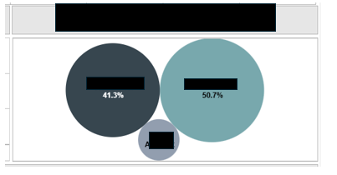

* Histogram (example from outside source)

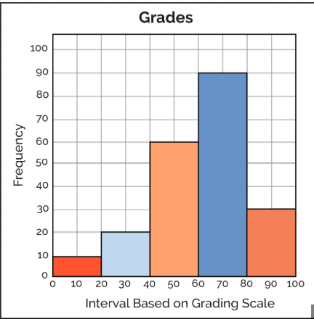

* Treemap Diagram (example from outside source)

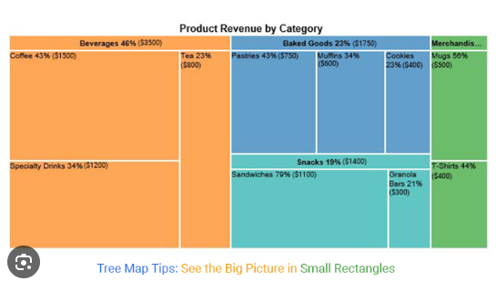

* Sankey Diagram (example from outside source)

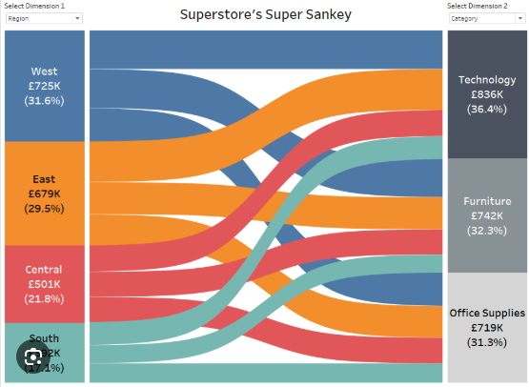

* Heat Map (example from outside source)

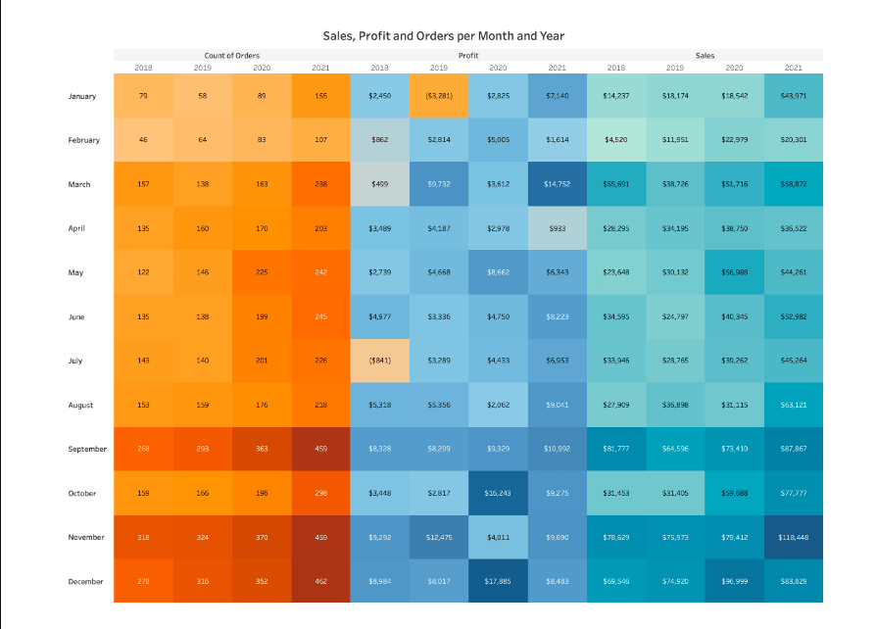

* Gantt Chart

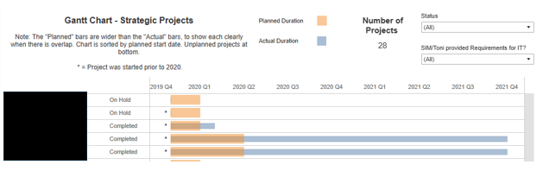

* Waterfall Chart (example from outside source)

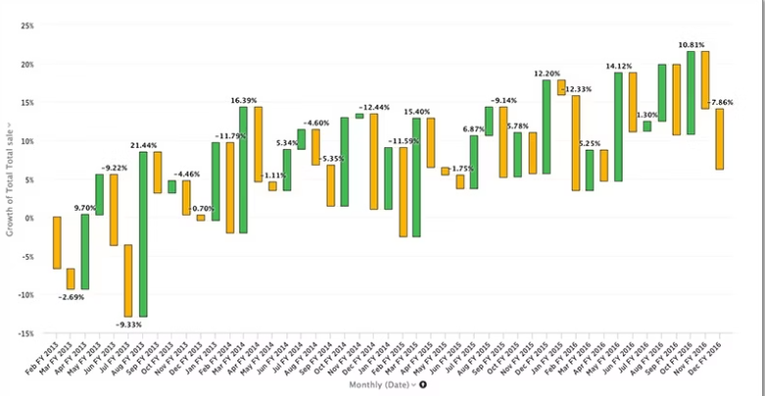

**Advanced Analytic Features**

* Forecasting and Predictive Modeling
* Geospatial Analysis
  + Example:

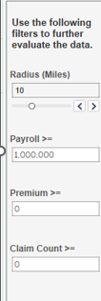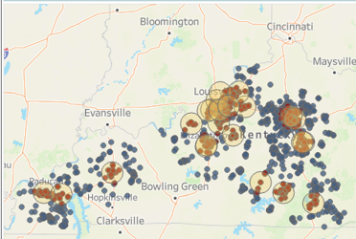

* Level of Detail (LOD) expressions - controlling granularity of data you want to render.
  + LOD expressions provide a way to isolate specific levels of data in a visualization, regardless of the other filters or dimensions present. This allows for more precise and flexible analysis of data.
* Machine Learning (ML) and Artificial Intelligence (AI) Integration
* Statistical Modeling

**Advanced Tooltips and Links**

* Ability to open links to another dashboard in a new window so that the original dashboard remains available to the end-user.

**Advanced Integration**

* Ability to integrate with a Single Sign-On (SSO) authentication scheme.
* Ability for API access to extend functionality – interacting with JavaScript or REST API to gain additional flexibility/functionality in integrations.

**Scheduled Reporting**

* Potential ability to replace Crystal Reporting via scheduled data visualization and/or reports.
* Report Delivery:
  + Automated email notification that report is complete and/or errors have occurred.
  + Screenshots, PDF, Excel, and/or CSV attachments in automated emails.
  + Ability for correct user permissions and preferred filters to be applied in the received reports/visuals.
  + Link to dashboard with correct user permissions and preferred filters automatically applied upon arrival.
* Scheduling/Set-Up:
  + Ability for admins to manage subscriptions.
    - Creating user groups for receiving reports
    - Scheduling occurrence
      * On-Demand, Daily, Monthly, Yearly, Etc.
  + End-users to have the ability to schedule their own reports.

1. **Training Tools/Support**

Please describe the following:

**Training/Educational Resources**

* Availability of training resources to learn how to leverage tool to fullest capabilities.
* Established userbase/community for the tool
  + Can include product discussion forums where questions, issues, and quirks with the software are discussed with solutions provided.
  + User Conferences/Events

**Product Support**

* Identify response time based on severity of reported issues (non-critical vs. critical)
* Identify base level of support available through licensing agreement.
  + Identity any annual reoccurring costs above licensing costs.
* Start-up assistance/implementation services for initial product adoption.

1. **Pricing**

* Provide a full estimation of cost, including but not limited to whether there are costs associated with the following:
  + Licensing/pricing for internal KEMI users vs. external agent/policyholder users.
  + Licensing/pricing for internal KEMI development users vs. internal KEMI viewer users.
  + Pricing for implementation services to assist in converting existing dashboards to new software.
  + Pricing for training.

1. **Business Continuity Form**
2. Complete the Business Continuity Form which is attached to this RFP, and return it as a separate attachment with your response. You must utilize the Business Continuity form for your answers.

**III. INSTRUCTIONS**

**READ ALL INSTRUCTIONS CAREFULLY.**

**FAILURE TO DO SO WILL BE AT THE OFFEROR’S RISK.**

1. Proposals must set forth full, accurate, and complete information as required by this RFP. Failure to follow these requirements may be cause for rejection of the proposal.
2. KEMI is not liable for any expenses incurred in the preparation and presentation of the proposal.
3. The Offeror Form located in the addendum must be signed by the person submitting the proposal and must include the signee's printed or typed name, business address, email address, company website, telephone number, and date. This form must be submitted with your proposal.
4. The Sworn Statement Regarding Campaign Finance Laws Form located in the addendum must be signed, notarized, and submitted with your proposal.
5. The Proposal Submission Checklist located in the addendum is included to ensure accurate and complete submissions.
6. Proposals must be submitted electronically via KEMI’s online submission portal as specified on the first page of this RFP. Unless stated otherwise in the RFP, it is **strongly preferred** that the entire proposal is submitted in a single PDF document. If separate attachments are also submitted, they must be clearly labeled and timely submitted. Please note that only a maximum of ten (10) attachments can be submitted through the online submission portal. No other method of correspondence will be accepted.
7. **The Proposal Deadline Date and Time are the date and time indicated on the first page of this RFP. The date and time that KEMI actually receives the proposal will determine whether the applicant has met the deadline for response.**
8. All inquiries concerning the form and method or specific services/products as well as requests for copies of the RFP must be made in writing to:

Sarah Kosin

[rfp@kemi.com](mailto:rfp@kemi.com)

Responses to inquiries will be shared with all potential Offerors having received a copy of this RFP from KEMI. Therefore, distribution of this RFP must be handled directly by KEMI. Any unauthorized contact with any KEMI staff other than as specified above may disqualify the Offeror from further consideration.

**IV. GENERAL INFORMATION**

A. Background

KEMI was created in 1994 by the Kentucky General Assembly to provide workers’ compensation insurance to Kentucky employers. KEMI is Kentucky’s largest writer of workers’ compensation insurance with its headquarters located in Lexington, Kentucky. For additional information about KEMI, please visit [www.kemi.com.](http://www.kemi.com.)

B. Discussions with Offeror

Discussions may be conducted with all responsible Offerors who submit proposals and are determined to be reasonably qualified and susceptible of being selected for award. Discussions may be for the purpose of clarification to assure full understanding of, and conformance to, the proposal requirements; however, Offerors will not be permitted to change their original proposal. Offeror should clearly understand that any verbal representations made or assumed to be made during any oral discussion held between Offeror and KEMI are not binding.

KEMI may require Offerors among the top scoring proposals to participate in a virtual interview. See aforementioned Schedule of Events. The principal contact for KEMI will be required to participate in the interview.

C. Proposal Modifications

Any changes, amendments or modifications to a proposal after it has been submitted must be made prior to the deadline for receipt of proposals, must be in writing, and must be submitted in the same manner as the original proposal.

Proposals or modifications received by KEMI after the exact hour and date specified shall not be considered.

D. Confidentiality

Matters relating to this RFP and any resulting contracts shall not be discussed with anyone other than KEMI staff without the prior written consent of KEMI. No opinions, reports, summaries, letters, or other documents prepared with respect to the RFP shall be released without approval of KEMI, except as required by state or federal law.

Except as required by law, information furnished by any Offeror in response to this RFP will not be disclosed by KEMI without the prior written consent of the Offeror.

E. Reservation of Rights

KEMI reserves the right to:

1. Reject any or all proposals and waive any requirement, informality, or condition of proposals.
2. Cancel the RFP and not award the RFP.
3. Prohibit sub-contractors of the Offeror from performing any of the Services outlined in this RFP without the prior written consent of KEMI.
4. Categorize Offeror as an independent contractor, denying any employee/employer relationship between KEMI and Offeror.
5. Approve the time and format of payment for the Offeror(s). KEMI will audit fees for reasonableness and accuracy.
6. Add items or services within the scope of the resultant contract if mutually agreeable by both the Offeror and KEMI.
7. Amend this RFP. Any amendment or information provided to a prospective Offeror will be provided to all prospective Offerors. If necessary, an RFP based on revised specifications will be issued as promptly as possible.
8. Perform services in-house, or to contract with another company to perform like services.
9. Require a contract with the winning Offeror(s). Contract negotiations will commence at the conclusion of the RFP process.
10. Registration with the Kentucky Secretary of State

By responding to this RFP, the Offeror agrees and acknowledges that:

1. If the Offeror is a foreign entity as defined under Kentucky Revised Statute (KRS) 14A.1-070(10), and it is awarded a contract, it will ensure that it is properly registered with the Kentucky Secretary of State in accordance with KRS 14A.9-010 during the life of any contract awarded, or otherwise document the legal exemption which applies.
2. If the Offeror is a Kentucky entity as defined under KRS 14A.1-070(7), and it is awarded a contract, it will ensure that it is properly registered with the Kentucky Secretary of State in accordance with KRS Chapter 14A, or otherwise document the legal exemption which applies.

The aforementioned information shall be maintained during the life of any contract awarded and provided to KEMI upon request.

1. Protest

Any offeror who is aggrieved in connection with the solicitation or award of a contract may file a written protest to KEMI’s Internal Auditor within fourteen (14) calendar days after such aggrieved offeror knows or should have known of the facts giving rise to the protest.

Patrick Simpson

[psimpson@kemi.com](mailto:psimpson@kemi.com)

**OFFEROR INFORMATION:**

***IMPORTANT*: SUBMISSION MUST CONTAIN ORIGINAL SIGNATURE**

Signed by:

Date:

Type or Print Name:

Company:

Address:

City: State: Zip:

Phone No. (Area Code)

Fax No. (Area Code)

Email Address:

Company Website:

Federal ID or SSN #

Type of ownership: Individual Sole Proprietorship

Corporation Partnership

In addition to the principal contact listed above, please include below any additional contacts you would like to receive communication regarding the RFP. KEMI will only send communication regarding the RFP to the principal contact and the contact(s) listed below. The information includes, but is not limited to, KEMI’s responses to inquiries, status updates about the RFP, any modifications to the RFP, requests for interview scheduling, etc.

Contact Name(s) for RFP Communication:

Contact Email(s) for RFP Communication:

**Sworn Statement Regarding Campaign Finance Laws:**

**Pursuant to KRS 45A.110 and KRS 45A.115**

*This sworn statement regarding campaign finance laws must be signed and notarized and returned with your proposal.*

The undersigned hereby swears or affirms, under penalty prescribed by law for perjury, that neither he/she, individually, nor, to the best of his/her knowledge and belief, the corporation, partnership, or other business entity which he/she represents in connection with this procurement, has knowingly violated any provisions of the campaign finance laws of the Commonwealth of Kentucky, and that the award of a contract to him/her, individually, or to the corporation, partnership or other business entity which he/she represents, will not violate any campaign finance laws of the Commonwealth.

OFFEROR

(Signature)

(Title)

(Name of Company or Corporation)

State of )

) SS

County of )

The foregoing statement was acknowledged and sworn on before me this _________ day

of , _______.

Notary Public

My Commission expires: .

**PROPOSAL SUBMISSION CHECKLIST**

The vendor MUST include the following with the proposal submission.

If the items below are not submitted with the proposal submission,

KEMI will reject the proposal and the Offeror will be disqualified.

**⇨ SIGNED OFFEROR INFORMATION FORM**

**⇨ SIGNED AND NOTARIZED SWORN STATEMENT REGARDING CAMPAIGN FINANCE LAWS**

**⇨ COMPLETED BUSINESS CONTINUITY FORM**

**⇨ ORIGINAL COPY OF THE PROPOSAL**

**(prepared in accordance with the Specifications and Requirements described in this RFP)**